Senate throws Governor Mutua for being clueless

The Senate Public Accounts and Investment Committee said Dr Mutua did not have requisite documents for the scrutiny of expenditure for the 2014-2015 financial year thus was turned away from the hearing.

Dr. Mutua was summoned to respond to audit quieris, the committee chairman quoted” . “We want quality to be the heart of our proceedings. It will not be productive for us as a committee to continue with this session without seeing the documents you are referring to in your responses,” Senator Moses Kajwang’, the Chairman of the committee told Mutua yet he had submitted the required documents to the office of the Senate Clerk last year

“I am appearing today over the same issue that I was supposed to respond to last year before the elections. My assumption was that the documents I submitted last year are still valid and figured out that we don’t need to incur extra costs making photocopies,” he said. He apologised and said the error was caused by miscommunication. In his report, the Auditor General said the governor's office had not provided documents to show how Sh7 billion was spent. In the absence of the supporting documents, the manner in which the amount was spent could not be confirmed, Mr Ouko said.

was spent on salaries while Sh1.3 billion bought goods and services. Some Sh1.9 billion spent on acquisition of assets.

All Makueni Women should sleep Commando Style – Rose Museo

Makueni County MP, Rose Museo, has urged Kamba women to sleep without panties to reduce defilement cases in the region, and ensure that their men are ‘happy.’

According to Museo, women who go to bed fully clothed deny their husbands conjugal rights, making them unhappy at work. She wants ‘national reconciliation’ to start in bed.

“Part of the anger experienced among many Kenyans starts at the family level. When a man leaves the house unhappy, he cannot serve his country well,” said Museo.

The outspoken Woman Rep has threatened to publicly undress adults caught in defilement cases because “we will not sit and watch as the future of our young girls is being destroyed. Whenever the government delays to take action against such culprits, I will mobilise fellow women to publicly humiliate the suspects buy undressing them in an open market to see how big his manhood is.”

The MP cautioned women against neglecting their husbands because women are the unifying factor in the family.

“Be brave and treat your husbands well so that they leave their house for work happy men. That way, they will serve the nation well,” she told The Nairobian.

Museo, who is among 14 nominees of the Building Bridges Committee that was set-up after the Raila-Uhuru handshake, disclosed that the journey to building bridges in the country will only be effective if it starts at the family level.

“When there’s peace in Kenyan marriages, the society and country will be peaceful,” she said.

The MP encouraged women to continue working together in groups to ensure economic empowerment in villages.

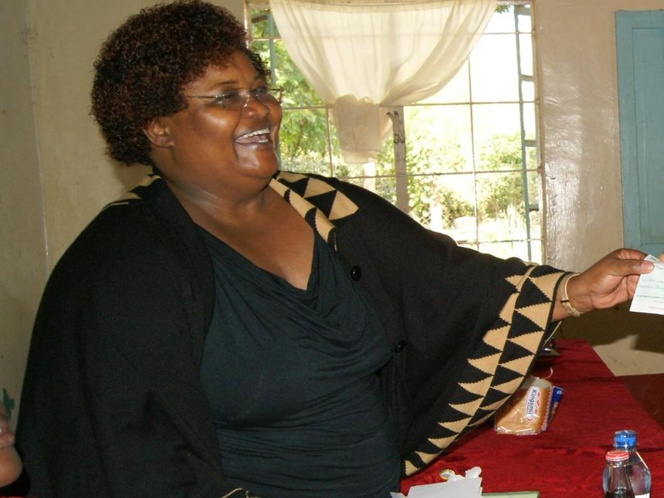Rose Museo

She concluded by saying:

*WHEN THERE’S PEACE IN KENYAN MARRIAGES, THE SOCIETY AND COUNTRY WILL BE PEACEFUL.*

While I agree with her sentiments, her delivery might be misconstrued. Her end game is for women to please their husbands sexually. This is to stop them from engaging in heinous behaviours because they have been denied conjugal rights.

My problem with her thinking is that it conflates men who defile with men who are n’t getting good loving from their wives.

That I think is an error. The sad truth is that there will always be bad men. Not all but some who engage in this vile behaviour. Will their wives sleeping *ndethe*help them, sadly I don’t think so.

Ndengu glut now forces counties to devise ways to cushion farmers

Ndengu, described as green gold by proponents, the tiny legume is threatening to break and make political careers in Lower Eastern. Rallied by politicians into planting green grams (ndengu) with the promise of good prices, farmers churned out bumper harvest in Tharaka Nithi, Kitui and Makueni but now the chickens have come home to roost with a ruthless market and poor prices.

In Tharaka, Governor Muthomi Njuki is holding onto a vague promise by Deputy President William Ruto that the government will begin buying the produce for strategic grain reserves after putting in place concrete modalities. In Kitui, Governor Charity Ngilu is precariously clutching onto an equally inexplicit assurance proffered by former Prime Minister Raila Odinga that India will buy 100,000 tonnes of green grams each year from Kenya. And in Makueni, the County Government and the County Assembly have stepped in to buy the produce from restless farmers and scout for markets later. “We want green grams to be bought by the government just like maize. We’ll convene a meeting of leaders from the affected counties with officials from the ministries of devolution, agriculture, security and public service to implement the plan,” DP Ruto said in Tharaka two weeks ago. Throughout the three counties, the ndengu story is of desperation, urgency and concern over a commodity whose price has fallen from Sh100 a kilo to Sh40. But it is in Kitui where the story is threatening to spill out of hand forcing Wiper Democratic Movement leader Kalonzo Musyoka and Raila to come to the aid of the Governor last week. “This is not time for blame game. Give the governor time to work and join her in looking for solutions on the green grams glut,” Kalonzo told Kitui leaders last week in a jab directed at area Senator Enock Wambua who has fallen out with the Governor over the matter. Mr Wambua is opposed to the manner in which the county government is handling the ndengu glut. He wants the county government to buy the produce at Sh100 a kg and look for market. Speaking during an event at Prof Makau Mutua’s home, Kalonzo turned the heat on Kitui County Assembly members whom he accused of lacking foresight in addressing the ndengu crisis. He urged the MCAs to pass legislation to cushion farmers from losses due to falling prices.

“You need to demonstrate that this is indeed a green gold by coming special legislation to safeguard from the exploitative market and ruthless middlemen,” Kalonzo told MCAs at the event. At the Kitui bus park where Kalonzo and Raila had a rally after the event, Ngilu who has in the past received a euphoric reception was stunned when the crowd turned cold on her. It was a clear pointer that the green grams debacle was a big disappointment to the locals. However, the presence of the two NASA co-principals appeared to calm the residents. Raila tried to make amends by claiming he had struck a deal with Indian Prime Minister Narendra Modi to lift the ban on pulses, including green grams from Kenya. But as Kitui farmers cry for help, farmers in the neighboring Makueni County are set to smile their way to the bank after the county government pumped millions to buy green gram harvest. The county government has partnered with 125 self-help groups and cooperatives whom it will lend the money through Tetheka Fund - a county government social fund to cushion ndengu farmers from losses. The groups will buy the produce at Sh55 per kilo. The Tetheka Fund is an initiative of Deputy Governor Adelina Mwau. Green Gram Value Chain Coordinator Charles Ndungu, says the groups will sign contracts with farmers to buy the produce which will then be stored at designated centres across the county until prices improve. ALSO READ: Fight against fall army worm goes mobile “If they sell at Sh100 per kilo, they will pay back a certain amount to the farmer as per the signed agreement,” Ndungu said. Just like Kitui County, Makueni produced slightly over 30, 000 metric tonnes of green grams. Kenya Red Cross Society Secretary General Abbas Gullet described the green grams glut as the epitome of success towards attaining food security in the country.

Dr Mutua **defies ward reps and appoints Ministers**

Dr Mutua cited section 9 of the Public Appointments (County Assemblies Approval) Act, in making the appointments, saying the members are deemed to have been approved after the lapse of the 21 days from the date he submitted the names.

Machakos Governor Alfred Mutua on Friday appointed seven ministers despite lack of approval by the county assembly.

Section 9 states: “Unless otherwise provided in any law, a committee shall consider a nomination and table its report in the County Assembly for debate and decision within twenty-one sitting days from the date on which the committee first sits to consider the nomination.”

Mr Mutua said he made the appointments in the best interest of the Machakos people.

He said the assembly rejected his initial five ministers after which he resubmitted to the assembly another list of nominees.

"The assembly failed to approve the nominees within 21 days as required by the law," said Mutua.

Mr Mutua spoke during a press conference outside his Machakos office where he was flanked by his deputy, Mr Francis Maliti.

**APPOINTEES**

Ms Evelyn Mutie has been appointed to take charge of the energy, lands, and housing docket while Mr Morris Aluanga will head the roads, transport and public works ministry.

Mr Titus Nzeki will be in charge of the county administration and decentralised units while the former county secretary Francis Mwaka moves to the trade docket.

Mr Kimeu Kimeu will head public service while Mr Urbanus Musyoka will lead the agriculture docket.

Mr Lazarus Kivuva has been tapped to lead the education ministry.

Farm ponds offer a unique integrated solution for Kitui County, Kenya

BY [DANYELL ODHIAMBO](http://blog.worldagroforestry.org/index.php/author/danyell-odhiambo/) · JULY 20, 2018

**1**

[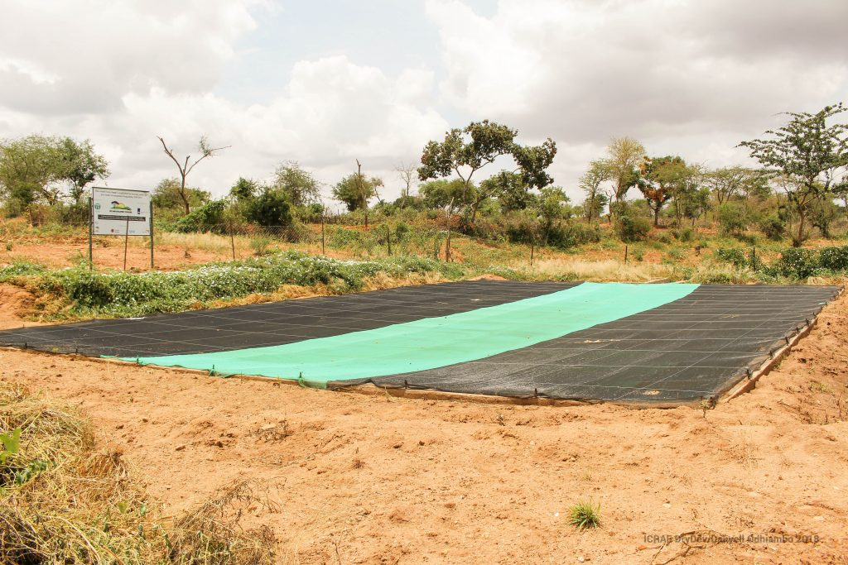](http://blog.worldagroforestry.org/wp-content/uploads/2018/07/IMG_3800.jpg)

*A covered farm pond established by the Adventist Development and Relief Agency (ADRA) at Kanyangi, Kitui County, Kenya. Photo: World Agroforestry Centre/Danyell Odhiambo*

***Farm ponds are quickly emerging as novel hubs for integrated, climate-smart technologies promoted through the Drylands Development programme in the vast semi-arid landscapes of Kitui County in eastern Kenya***

Water shortage occasioned by prolonged drought has been a major hindrance to growth of the agribusiness sector in the drylands of Kenya. The [Drylands Development](https://drydev.org/about-drydev/) (DryDev) programme aims to reverse this trend by assisting smallholders to harvest rainwater for crop production through construction of simple farm ponds.

DryDev is led by the World Agroforestry Centre (ICRAF) in partnership with five national lead organizations and 13 implementation partners in Burkina Faso, Ethiopia, Kenya, Mali and Niger. The programme is funded by the Ministry of Foreign Affairs of the Netherlands, with substantial contribution from World Vision Australia.

The programme has adopted the farm-pond initiative to disseminate a package of interventions: building capacity in agricultural commodity production, on‐farm water and soil management, enhanced access to markets and links to financial services. To maximize benefits from the ponds through integrated systems, DryDev trained farmers’ groups in agroforestry.

*“As a result, we have planted a lot of trees on our farms,” said Mary wa Kimali, a member of Kyeni kya Zangathi farmers’ group, “and established tree nursery enterprises of local indigenous species, particularly, pesticidal plants and trees that help protect against pests and diseases.”*

“Some farmers established tree nurseries using water from the ponds,” explained Eric Wanga, DryDev manager for Kitui County, from Adventist Development and Relief Agency (ADRA). “This has contributed to enhancing community access to tree seedlings and, hence, adoption of agroforestry. Agroforestry and farmer-managed natural regeneration conserve water and soil, which improve crop yields. In addition, community groups can establish other enterprises, such as beekeeping, around the farm pond.”

The farm ponds form part of the programme’s interventions that were recently assessed during a joint quality monitoring exercise on 5–6 March 2018 in Kitui County, undertaken by ICRAF, World Vision Kenya, ADRA, SNV and Caritas.

In Kitui, the ADRA helped establish 20 farm ponds, one sand dam and one earth pan in the Lower Yatta sites of Kanyangi and Waita. In addition, 376 hectares now feature climate-smart agricultural practices. DryDev also supported smallholders in adopting alternative water-buffering structures that require less investment than ponds, such as [‘zai’ pits](http://blog.worldagroforestry.org/index.php/2018/01/19/pick-spade-may-triple-farmers-yields-kenyan-drylands/), sunken beds and terracing. This comes against a backdrop of efforts by the Government of Kenya to establish a National Water Storage and Harvesting Authority and the establishment by ICRAF, World Food Programme and other partners of the [Billion Dollar Business Alliance](http://blog.worldagroforestry.org/index.php/2017/05/10/kenya-launches-national-program-to-harvest-rainwater/), which is expanding the use of integrated farm-pond systems.

“Stabilizing smallholders’ crop yields under the changing climatic conditions in Sub-Saharan Africa requires unique adaptation strategies focused on soil and water management,” explained Maimbo Malesu, ICRAF’s expert on water harvesting. “In-situ technology consists of storing water in areas where it is going to be used. This reduces reliance on rain-fed agriculture by providing water for irrigation in areas where groundwater resources are scarce or inaccessible.”

[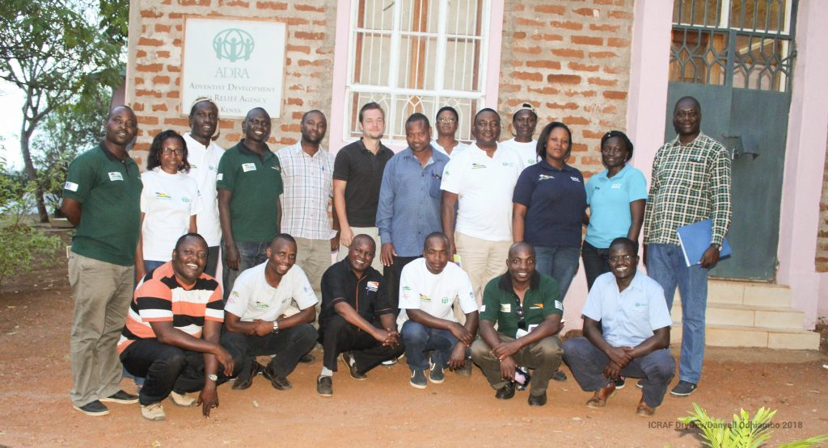](http://blog.worldagroforestry.org/wp-content/uploads/2018/07/IMG_4044.jpg)

*The DryDev Kenya team in Kyusani, Lower Yatta, Kitui County. Photo: World Agroforestry Centre/Danyell Odhiambo*

Thinukya Andu self-help group was among the seven groups visited during the monitoring exercise in Kanyangi. The 30 members mostly produce agricultural commodities, such as green gram or mung bean (*Vigna radiata*), and engage in table banking (collective savings and loans schemes) and poultry rearing.

Through DryDev, members had constructed a 250 m3 farm pond, complete with an irrigation pump; a sand dam along a nearby riverbed to provide clean water for domestic use; and were trained in rainwater harvesting, micro-irrigation, marketing and access to credit. The harvested water supports horticultural value chains and DryDev builds the capacity of farmers to invest in drought-tolerant value chains.

Mercy Mwangangi, a member of Thinukya Andu, knows only too well the importance of taking calculated risks, one step at a time.

“I was initially a subsistence farmer but through the training offered by DryDev I took the risk of venturing into agribusiness,” she said. “Armed with my new financial literacy skills, I approached a microfinance institution and borrowed Ksh 80,000 (USD 800) to cover the cost of excavating a farm pond. The project supported me to fence the pond and provided a dam liner and shade net.”

[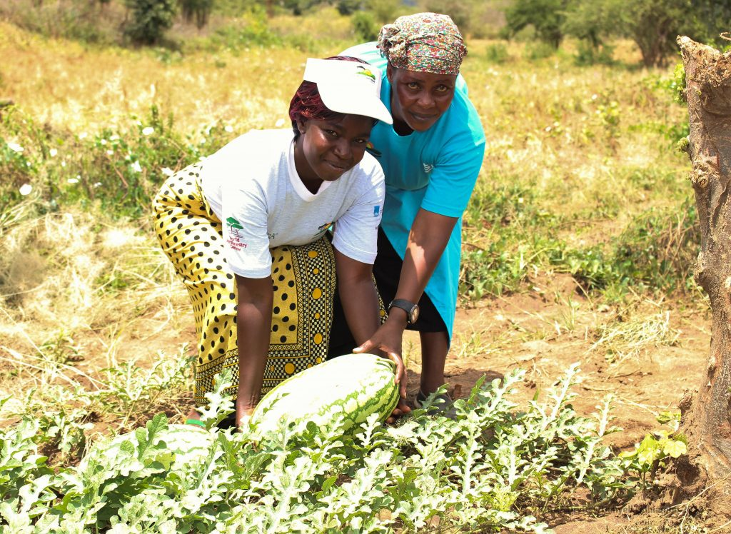](http://blog.worldagroforestry.org/wp-content/uploads/2018/07/IMG_3765.jpg)

*Mercy Mwangangi and Anne Chale, both of Thinukya Andu, holding a melon grown with water from a farm pond. Photo: World Agroforestry Centre/Danyell Odhiambo*

Mwangangi adopted water and soil conservation techniques that allowed her to diversify her crop production, cultivating high-value crops such as watermelon, tomato, green gram and cowpea, that accelerated the returns on her investment.

*“It is really encouraging to see that DryDev is revolutionizing farmers’ initial negative perception towards acquisition of loans,” said Jonathan Muriuki, ICRAF Kenya’s country representative. “Our next frontier is to orient the financing towards the intensification of commodity production around farm ponds to ensure that farmers double up as traders.”*

Designing good business plans is a key part of smallholders’ transition from subsistence to commercial farming.

“Once a farmer develops an agribusiness idea, the business plan should begin addressing a number of issues: the institutions that one should engage with, the viable value chains and technologies that should be put in place,” said Ronald Ng’etich, DryDev associate director from World Vision Kenya. “This will motivate sustainability by creating a sense of ownership and involvement.”

[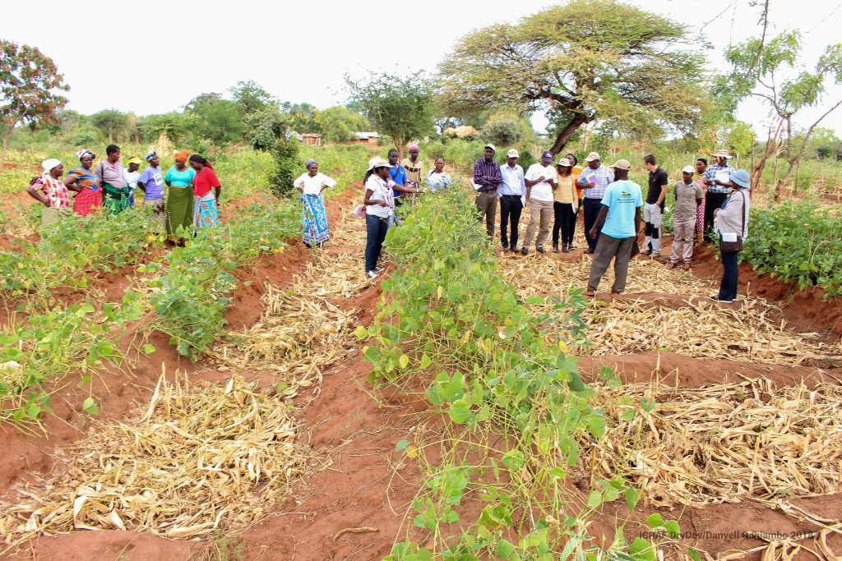](http://blog.worldagroforestry.org/wp-content/uploads/2018/07/IMG_3603.jpg)

*A green-gram farm managed by Ngomoni farmers’ group in Kitui that uses zai pits and sunken beds. Photo: World Agroforestry Centre/Danyell Odhiambo*

According to ADRA, 5515 farmers in Kitui County have received water and soil management training and 8130 were equipped with skills in production of agricultural commodities.

<http://blog.worldagroforestry.org>

# Makueni to host Para-Volley in August

Volleyball teams for Persons living With Disabilities (PWDs) across the country are set to compete in a Volleyball Tournament slated for August 23 in Wote, Makueni County.

The competition will be used to pick a team that will represent Kenya during Africa’s Para Volleyball Championship scheduled for Rwanda later in the year.

According to Bomet County Para Volleyball chairman Charles Kirui, counties in Kenya that have the Para Volleyball teams are expected to grace the Wote tournament.

He revealed that Bomet County is one of the counties that will send a team to compete in the tournament.

“We already have a team called Bomet Para Volley-ball team or Bomet Sitting Volleyball team and we will be in Wote. We’re currently training hard for the task ahead. We’re optimistic of emerging victorious in the coming tournament so that we proceed to Rwanda to represent our country. In fact, we’re raring to go,” said Kirui at a Kericho hotel yesterday.

Kirui called on the national government to chip in and support counties that will send their teams to Wote saying most of the teams are facing serious financial crisis and need assistance in a bid for them to do well in the coming tournament.

He at the same time called on the counties in South Rift region to support sports for people living with disabilities.

Kirui said there was need for the counties of Bomet, Kericho and Bomet to set aside funds aimed at improving and encouraging the disabled people to engage in sports.

“There’s a huge potential of sports among people living with disabilities but the counties and even national government have not supported them to hone sport skills. I therefore, appeal to the counties to set aside funds for these as soon as possible,” said Kirui.

“We are very ready to participate in various sports as per our disabilities but we don’t have equipment and facilities for these sports,” he added.

He observed that there was need for counties to support such persons as a way of enabling them get means of livelihoods. It will enable the country too to bag more medals during international championships or meetings.

Kirui noted that disabled people have proved they were able and thus the needed to be supported in a bid to take sports to the next level.

The Stray Lions batsman was not out as he faced 35 balls,posting two sixes and a boundary which were significant. Kenya next face Tanzania who stunned Uganda by six wickets win.

time for their match against Police, thus surrendering all three points to the law enforcers.

Who is Selecta Mickey

Hey Bro,

Would like to feature you on our website (kambanation.co.ke) on a segment named Entertainment/Lifestyle (know your Artist) but I don't know whether you have the time to share some info about yourself

1. Brief intro - where u were born, what do u do (school), siblings

Answer - born in Kitui, in the late 90s🤣 ,,schooling at Moi university West Campus taking BA Political science and public administration.

2. How did u start & do u balance btn the other Business (school n any other thing you do)

Answer - Started way back in high school..I loved music ..attended lotsa events so I would peek and see what the DJs did...I'm a fast learner so that's how it came along

I made more dj friends...they coached me to where I am...plus Practice

Discipline helps me balance school and djing...I know what to do at what time.

3. Why choose DJ-ing

Answer- One thing about Djing, its fun man..imagine earning from having fun.

4. Do you make money from it? Is it a career

Answer- Yea I make money...every gig brings money... Yes its a career, guess I'll have two after I graduate🤣🤣

5. Do you have a management or Crew?

Answer- Currently I don't have management or crew...I work with some friends ...kupeana 411 bout upcoming gigs 😋😅

6. Biggest challenge u have ever faced or u face

Answer- mostly...technical issues in the middle of an event

And maybe getting underpaid ...as opposed to terms agreed earlier... Where the need of a manager comes in☹

7. Your greatest breakthrough - when did it happen n how

Answer- When I saved enough to buy my own machine... More gigs more money

Saved a lot on hiring 😇

8. Parting shot to your fans

- where to get you on the DJ Decks

Answer; Check media for updates on upcoming events

- Where to get your Mixes

Answer-

You can join my telegram channel

t.me/selektamickey

Or on mixcloud

www.mixcloud.com/selektamickey

- Social Media & hook you up for

services (contact Phone & Email)

Contact:0717909151

E-mail:selektamickey254@gmail.com

Facebook:Selekta Mickey

Instagram:selekta_mickey

Twitter: @MickeySelekta

Something else..

We having our second edition of The Tribe Kenya Colour fun affair.. This August 25th 2018 to be held at Machakos Academy. From 10Am till late.

Come let's have fun

Tickets going at 400 Bob

You can catch me live on the ones and twos.

**Machakos Launches Local Talent Search On Film Production**

KNA July 22, 2018 Machakos, News, Politics, Technology 0

The Machakos CEC in charge of Tourism, Faith Wahome addressing some of the film producers who attended the launch of Machafest 2018 at the Machakos Peoples Park on Thursday July 19, 2018. Photo by KNA.

The Kenya Film Classification Board (KFCB) Communication Corporate Officer, Nelly Muluka while addressing the event. To her extreme left is Machawood CEO, Victor Muniafu, Machakos CEC for Tourism, Faith Wahome and former KCFB Chairman, Peter Mutie on Thursday July 19, 2018. Photo by KNA.

Machakos County has launched its third edition talent search competition for enterprising local film producers.

Dubbed Machakosfest2018, the contest which is expected to draw hundreds of local and international producers is also meant to promote and reward upcoming artists in the country.

While briefing the press on Thursday during the launch, Machawood CEO, Victor Muniafu said the county government had given the green light for producers to use the existing historical and cultural sites in the area in coming up with a seven minute film.

He said producers are at the liberty to partner with others in their work with the deadline submitting the edited footage slated for November 3, 2018.

Auditioning are expected to take place on December 15, 2018.

Overall winners will take home Sh.1 million in cash prize while runners up will pocket Sh.500, 000.

Second runners up will take Sh.250, 000 while the fourth best film will rake in Sh.100,000.

“This is a competition that seeks to promote local film and promote cottage development and Machakos as a film destination .One of the requirement is that if you have to promote tourism in Machakos is that you have to shoot two scenes within Machakos County,” he said.

Entries into the competition have been grouped into Professionals, tertiary colleges, universities and schools.

Muniafu said the county will assist the entrants with logistics and geographical information of the county to enable them identify the most scenic places of their choice before carrying out their shooting.

And unlike where film makers are required to pay before undertaking any shooting, the county government has waived all charges to ensure many people try their hand in the prestigious completion which attracted 71 entrants last year.

On her part , Kenya Film Classification Board (KFCB) Communication Corporate Officer, Nelly Muluka pledged the board’s support to the county governments in coming up with local film content to help tap in upcoming talent.

She said as an agency, they will continue playing their watchdog role of ensuring that Kenyans get films that adhere to the rule of law, the country’s morals and diverse cultural heritage.

Muluka said the country’s film potential which rakes in at least s 200 million annually remains hugely untapped and called upon upcoming individuals and groups with a passion in the field to come out and invest in the sector .

“We are the main sponsor of Machafest 2018 and we are sponsoring them because they advocate for clean content and we are asking anybody who is submitting film to try his best to promote our culture, our national values and you tell good content that tells the beauty of our country and Machakos County,” she said.

The official further revealed that other than undertaking a regulatory role on local content for both TV and film, the board was planning to transform a number of public amphitheaters into premises where enterprising artists will have a chance to showcase their budding talents and get a chance to be nurtured through stage based trainings.

One of the premises expected to be turned into a talent nurturing center include the Kenya Cinema which will be turned into the Nairobi Excellent Talent Center.

Also present during the colorful ceremony was Prof. Humphrey Oborah who is the current President of World Talent Federation, Machakos CEC on Tourism, Faith Wathome and former KFCB Chairman, Peter Mutie.

Faith Wathomeformer KFCB chairmanKFCB Communication Corporate OfficerMachakos CEC on TourismMachakosfest2018Machawood CEONelly MulukaPeter MutiePresident of World Talent FederationProf. Humphrey Oborahtalent search competitionVictor Muniafu

**The controversial Masaku seven's rugby event is back**

2 days ago Ndeto Jaythree

Ladies clubbing during the masaku sevens in 2014 in Machakos county rugby sevens. [Photo/standard]

Some call the event Sodom and Gomorrah,hell in Masaku and others call it pornography at its peak because of series of events which happen during the Masaku sevens events.

Win a free Ksh 1,000 bus ticket! Click here and complete a 3mins survey for BuuPass.

The behaviour shocked many. Ladies nearly naked,unprotected sex was done at day light and alcohol was taken until Machakos town clubs went dry.

But guess what,the event is back.

The event was announced on Masaku RFC's Facebook page and on Twitter last week and is set to happen on 21st to 22nd of September 2018.

"Welcome to this year's Masaku sevens rugby event which will happen on 21st to 22nd September 2018."

The event which brings Kenyans from different parts of Africa and all walks of life was critisised by churches and other dignified institutions in 2014.

The then NACADA chairman Mr John Mututho blaimed the Machakos county government for failing to control sale of alcohol.

Mututho allegedly received complains from many churches.

"That's a failure on Mutua's part. It's his business to ensure that the licensed people handle alcohol properly and drugs and pornoraphy properly. It is all in the domain of county," Mututho said.

Children as young as 11 were sold alcohol, nudity and sex was done in public.

Let's wait and see how this year's Masaku sevens will be.

I nearly grew up going to 'Kamandiko' [Kamba benga dance nights] with little knowledge about exotic and urban music.

Am not saying that Kamba music is bad but diversity is cool.

This man Deejay Rocky brought change in music during our times as youth.

From benga, he introduced reggae music roots, dance hall and local  tunes which were not much listened to in rural areas since people there were still naive.

Rocky used to play the likes of Bob Marley, Lucky Dube, Culture,The Wailers to Juacali and the late E-Sir.

Yes, he made us enjoy big tunes in reggae Jam sensations. He organized nearly every weekend in Local clubs around Machakos County.

Reggae tunes all the way from Jamaica and local rap from Nairobi City.

The renowned Deejay Rocky Mutuku from Mitaboni town in Kathiani, Machakos County has been on the decks for decades and yes he's not getting out soon.

"I used to do odd jobs before my breakthrough, but see God has blessed me. I have big business and I am a owner of one of most powerful Public address instruments in Kenya, " says Rocky.

Though he didn't disclose his businesses, one thing is clear that he is super talented and he has several awards under his name. If you contact him to come to your event, he definitely will and make surprises.

He will organize your event.

Find him one day doing his super mixes in clubs like Connection in Mlolong and Gellian Hotel in Machakos, you will never want to leave the mix and go home.

Dj Rocky has been a household name in Mitaboni area and he is now going international.

"I have a big show in Tanzania this week. I love all types of music so long as is good music. I will play," he added.

Rocky says he hangs out with mostly Kamba Benga artists, he plays their music too since he loves his heritage.

Rocky concluded the interview by stating that he keeps his family from limelight.

He didn't disclose much about the family.

**Best places to visit in Machakos County**

*3 days ago* [*Dylan klark*](https://hivisasa.com/profile/1998351f-aabf-45b9-8f7c-e00d3d249fbd)

Masinga Dam Resort in Machakos County. [Photo/nation.co.ke]

Machakos County is located in the Eastern part of Kenya. It borders Kajiado, Kiambu, Kitui and Makueni counties.

**Do you live in Machakos and would like to receive news updates for free?** WhatsApp the word Machakos to 0790870842

It has a lot of beautiful sceneries and places worth to make your holiday, some of which are mentioned below.

Best December holidays destinations in Machakos County include:

1. Kituluni Hill

On this hill, you can camp, hike or simply do a picnic. For residents and even prepared non-residents, a hill is a right place for physical exercises so as to keep fit. It has a beautiful view where water appears to be flowing against gravity.

2. Masinga Dam

Did you know that Masinga dam is found in Machakos County? Have you ever wished to catch a glimpse of how that electricity skillfully gets extracted from water? You better visit the dam in Machakos County. I assure you, it will be a learning experience you won’t forget.

3. Donyo Sabuk National Park

This national park commonly referred to as ‘The mountain of the buffalo’ since it's mountainous in nature, is forested with many wild animals inside. The sight of animals drinking water, feeding and simply co-existing in the park is a really awesome one.

4. Kenyatta Stadium

This stadium often holds games, sports, and other activities. You are likely to find ongoing events, so if you are a field person and you happen to be in Machakos, just head to the stadium.

An added advantage is that Machakos is close to Nairobi, so the transport cost that will be incurred for those around Nairobi will be relatively cheap. Pay Machakos County a visit, it will be worthwhile.

Police smoke out notorious drug peddler from Wote hide-out

A notorious bhang trafficker was arrested from his hide-out by police officers in Makueni. Police said they had been trailing the suspect accused of supplying the drugs across Makueni, Machakos and Kitui.

About 551 rolls of bhang and 500 stones were recovered with the suspect when he was arrested at slaughter Estate in the outskirts of Wote town. at 5. A.M. The suspect in his 40’s is alleged to be the most notorious bhang trafficker that police have been laying traps for over days. According to Makueni County Police Commander Joseph Napeiyan, the suspect was in company of other two male accomplices and they had arrived in the town from unknown region with the substance targeting unknown customers. “Police has been searching for this suspect till it dawn on him yesterday where we received a tip off that in company of other two had arrived in the town and rented a house in Slaughter Estate to sleep before proceeding with their business today (Tuesday). Our officers raided the house at around 5. A.M and arrested them

Kyalo, the most wanted suspect was taken in by the Criminal Investigations desk for further interrogations with the other two locked up in Makueni police station awaiting to be arraigned in Court. However, the Commander ordered for the circulation of the major suspect’s photo to all police stations in lower Eastern for further reports about him to be availed. He was described to be well-connected with other drug traffickers. This was not the first time police in Wote arrested victims of drug trafficking while in transit, Mutuku Mukumbi, Wote location chief has been arresting culprits in possession of Canabis Sativa mostly at the Bus Park and the source has never been known.

## **Affordable health: Saving Kenyans from high costs**

ou are one illness away from financial ruin”, or so the saying goes. And for three out of four Kenyans who are not covered by any health insurance, this saying rings all too true.

If they find themselves in the shoes of the one in five Kenyans who get sick every month, a fraction of them (16 per cent) fail to seek medical attention due to financial constraints. Another four out of 10 tough it out by selling their belongings or take loans to pay medical bills, but in the process, nearly a million or so are pushed into destitution by high healthcare costs.

For every hospital bill, Kenyans dig deep into their pockets to cover a huge chunk of it (a third).

**UNIVERSAL HEALTH COVERAGE**

Through the Big 4 Agenda announced by President Kenyatta last December, Kenya hopes to tackle the high-out-of-pocket costs by implementing Universal Health Coverage by 2022. The topic of universal health coverage took centre-stage at the recent Nation Leadership Forum, dubbed Our Health, Our Future, where thought leaders in the health space talked about Kenya’s journey to providing health for all.

Speaking at the forum, the World Health Organisation Country Representative for Kenya Rudi Eggers, explained that universal health coverage means that all people, not only in Kenya, but across the world, have access to basic health services that are of high quality, without suffering financial loss (or having to pay out of their own pockets for healthcare).

Central to universal coverage, according to the WHO, is access to a strong, efficient, well-run health system that meets the most important health needs of the communities it serves. That system must promote prevention of illness and healthy living, detect illnesses early and have capacity to treat them and rehabilitate patients. It must also be affordable, so that the people using it can do so without fear that they will run out of money.

It must provide essential medicines and technologies to diagnose and treat medical problems and employ a sufficient supply of well-trained and motivated health workers to provide services that meet the patients’ needs in the best way possible.

Also key to universal coverage, is access to health services in terms of geographical location (the recommended standard is that every person should live at least five kilometres from a health facility). However, as Dr Eggers noted during the Nation Leadership Forum, Kenya still has quite some distance to cover on this aspect.

“In many areas of the country, access to services still has to be built further, and not only the health facilities, but also health workers. It is very important that when you come to a health facility, there is a qualified and knowledgeable health worker who is able to treat you and has the means to refer patients to higher facilities if necessary; and has the right equipment,” he said during the forum.

In 2017, Kenya had 11,324 health facilities, but in some counties, residents still have to cover more than five kilometres on average to get to the nearest hospital. According to a report by the Kenya Institute of Public Policy Research and Analysis, 80 per cent of these health facilities are health centres and dispensaries which offer primary care, and 86 per cent have the basic medical equipment needed to provide general health services.

To meet the UHC goal by 2022, Kenya plans to scale up insurance coverage through the National Hospital Insurance Fund (NHIF), to reduce out-of-pocket costs from 26 per cent to 12 per cent in 2022. With this, the government hopes that Kenyans can be assured of treatment at minimal cost. This will mean boosting the number of NHIF principal members from the current six million to at least 13 million in five years.

But can Kenya really attain its lofty dream of Universal Health Coverage by 2022, eight years earlier than the global target of 2030?

**QUALITY CARE**

Experts who convened for the fifth Nation Leadership Forum emphasised that in order to achieve the provision of quality care, there needs to be equity, rather than equality. According to Dr Githinji Gitahi, who serves as Amref Health Africa Group CEO and Co-chair of the UHC2030 steering committee, universal health coverage means that those left behind are brought to the same level as those who can afford to pay for health services. He added that Kenya needs to change how it purchases healthcare, to make it more strategic, thus reducing wastage.

“We all purchase healthcare individually by paying out of pocket when we are sick, but we need to be more strategic. The wastage in the system is because we lack a strategic approach to purchasing health. We need to ask: What do we need to purchase, from where and at how much to get value for money,” Dr Githinji said, giving an analogy of a parent who pays each teacher individually to educate his child, versus parents who pay together for one teacher who provides education collectively to many children.

To achieve UHC however, he added, there must be political will and adequate allocation of resources, something that the government is yet to do.

“The country’s current budgetary allocation for healthcare is well below the Abuja Declaration of 15 per cent. Contrary to the current allocation of Sh4,000, to achieve Universal Health Coverage, we estimate that we need to allocate Sh9,000 per person annually. That means the government must step up its game,” he said at the Leadership Forum.

Makueni Governor Kivutha Kibwana, who has been able to implement a form of universal coverage in his county explained that all it took was doing the math.

“It’s actually very simple. We did the math: How many people come to pay in hospitals and how much do they pay? Suppose we take the 162,000 households and divide the amount? We found that if every household paid Sh500, we would be able to get the money that everybody pays when they come to our facilities. Through that we have 70 per cent coverage,” he said.

Beyond financing, the panellists noted that the government would have to ensure that health facilities have the requisite personnel and equipment to make quality health for all a reality. Access to the services and resources, availability of adequate and highly trained human resource and proper infrastructure are some of the key things that the experts advised the government to focus on.

“Our doctors are good and able. We just need to put resources in place, so that they are able to work. And so that we don’t get brain drain to the private sector, or more lucrative areas to other countries,” noted Dr Kahaki Kimani, an ophthalmologist and senior lecturer on the panel. She added that the entire human resource system from top to bottom should work to ensure a cohesive system that could deliver the services needed.

Already, the government has planned to pilot the UHC programme before national adoption. Four out of 47 counties were selected for the pilot, with Kisumu, Isiolo, Nyeri and Machakos being used as samples to generate the required feedback expected to guide a countrywide rollout. A sample size in the rest of the 43 counties will be 10,000 households, the Health Ministry had earlier announced and confirmed the news last week.

**AFFORDABLE MEDICAL CARE**

Some experts however feel that more needs to be done to not only assure the success of universal health coverage but to also make it affordable.

Dr Nelly Bosire, a gynaecologist and obstetrician and one of the panellists opined that to achieve Universal Health Coverage, the country needs to make good use of hundreds of medical officers it trains annually, instead of putting so much emphasis on specialists.

“We must understand that UHC is not driven by specialists. It is driven by general practitioners (GPs), who do the bulk of the work of reviewing the patient, diagnosing them, treating and making the differentiation on whether the patient needs referral or not. The GP offers a general package, one of the driving pillars of UHC,” she said.

To create the necessary resources for healthcare, Dr Bosire said that the government ought to curb wastage.

“Our resources in healthcare are already quite limited. That means we cannot afford to channel resources which are not necessary. The Managed Equipment Services is one example of major wastage, whereby for the last four years counties have been paying for a service they have not been using,” she said.

However, Chairman of the Kenya Healthcare Federation Dr Amit Thakker, noted that despite the urgency, UHC should be seen as a process, rather than as an event.

“It is also important to note that the whole idea of UHC is not anchored on shutting down any system, be it public or private facilities, but an ideology enshrined on partnerships and inclusivity to offer the next generation a better health system tomorrow than what we have today.”

Dr Thakker further added that the country should not solely depend on the National Health Insurance Fund (NHIF).

The panellists also noted that citizens should be empowered and informed to actively engage in healthcare decisions and in designing new models of care to meet the needs of their local communities.

“Having doctors or the necessary infrastructure is not enough. Makueni’s success comes from the awareness that they needed to invest in the infrastructure, bring on board the human resource and finally ensured a constant supply of the needed resources. If I have NHIF, visit my local hospital and I’m told to buy the drugs outside because the hospital has run out of its supplies I will feel robbed,” said Dr Bosire.

**Key takeaways:**

1. Focus on retaining health workers trained in the country.

2. Purchase healthcare in a strategic manner to avoid waste. Ask what do we want to purchase, how do we purchase it, and who do we purchase it from? To get more value for money.

3. Put resources in place to enable doctors and other health professionals to work and to prevent brain drain.

4. Focus on general practitioners who offer primary healthcare even as specialists are emphasised.

5. In many parts of the country, access to health services needs to be built further to boost access to facilities and qualified health workers.

6. Deploy an army of tech-savvy community health workers and integrate them into health system for universal coverage to be a success from the grassroots.

7. Focus on preventive health (immunisation, prevention of waterborne diseases, HIV, TB, and improved maternal and child health, nutrition and behaviour change).

8. NHIF is a principal player in delivering universal health coverage, but needs drastic reforms.